**October Newsletter**

**A Bicycle Built for Two  
Written by Judy Wieber**

On Sunday, August 20, 2023, SILO sponsored a lunch for Third Eye Insight’s (TEI’S) 9th Annual Tandem Bicycle Event.  The event took place at Heckscher State Park in East Islip.  A box lunch, consisting of a sandwich, chips, a cookie, and choice of Gatorade or bottled water were provided to all who participated. A trivia game equipped with lottery scratch offs to trivia winners, and accessible corn-toss game were a couple of new additions offered during lunch. Riders were also given hand towels marked with Third Eye’s logo as a take-a-way.

Over thirty blind and visually impaired riders donned in shorts, tank tops and sunscreen sat under the shaded picnic area at field 6.  Many chatted with old friends, waiting their turn, as tandems came back from their voyage around the park.  TEI recruited 6 captains, including SILO’S VERY OWN Tina Adamo and Alberta Galdi.  I got to talk with Tina, who explained: “It’s a great experience, I love watching the faces of the riders as they master the balance of the bike. A real sense of accomplishment and empowerment is felt.”  The captains, who are sighted, take the front seat, helping to pump and steer their blind counterparts.

5 of SILO’s employees and 1 member of SILO’S Board of Directors were found amongst the riders, in the stoker position, adding to the power of the team: Krista Giannak, Brandon Heinrich, Marilyn Tucci, Ecaterina Henter, and Judith Wieber. Brian Solomons could also be found noshing on sandwiches and playing trivia at lunch. Brian told me of how he loves coming out to the event every year.  “It’s a nice way to get some fresh air and catch up with old friends.”

Afterwards I got to interview Third Eye Insight’s founders, Sensei Devin Fernandez, and his sister Kim Fernandez. Kim Fernandez is the Executive Director, and she plays a huge role in organizing the event, and Sensei Devin Fernandez is the Program Director for TEI and schedules the events TEI offers. The following is the interview:

**Q:  How many hours of preparation go into organizing the event?**

*A:  We start announcing our summer schedule in early April and always like to hold this event in late August/early September. Most years we have been blessed by Mother Nature, except for one year when it rained in the morning.  We put out our request for volunteers about six weeks before. Our prep goes full force a month prior: tuning up the tandems, securing all permits and liability insurance, and obtaining a van rental to transport our bikes plus equipment.*

**Q:  What are some of the pitfalls, or challenges of putting together an event like this?**

*A.:  We put a lot of effort into getting as many people to participate as possible.   We want to make the event rememberable and awesome.  I know things come up, and things happen in life, but when people cancel at the last minute, it is disappointing.  This past event, we had 10 not show.  Having a big turnout is my thanks.  When we get many to come, I know it is because they truly enjoy the experience they had in the past and want to continue to have in the future. This way too, when we have an accurate head count, we can better budget our funds.  If we know in advance we need to plan for 30 instead of 45, we can allot the funds for other things, like advertisement, or water bottles.*

**Q.:  How many volunteers were you able to secure?**

*A:  Every year our volunteer list grows. This year, we had over fifteen. We are constantly doing outreach.  Some volunteers come and go, while others have returned every time.*

**Q:  How did you come to find the volunteers that captained the bicycles?**

*A:  Most of them come from word of mouth, including volunteers from SILO, such as Tina and Alberta. Our biggest challenge is finding captains. In the past, I have attended the Suffolk County Bike Riders Association meetings to recruit helpers.  The captain’s role is a very critical one, so we work year-round.  We greatly appreciate all our volunteers. Without them, we could not provide the services we offer.*

**Q.:  How many captains, how many bicycles?**

*A.:  Third Eye Insight owns four tandem bikes, allowing us to provide four rides at a time. Having more bikes would allow us to provide more rides to our participants.  We try to have at least six to eight captains every year. This year, we had six captains sign up and unfortunately, two were not able to come.  Fortunately, the four captains we did have were willing to stay on the bikes and continue to offer rides throughout the day. No doubt they were exhausted by the end.*

​

**Q.:  Was this the 9th annual?**

*A.:  This year would have been our ninth year; however, we did not hold the event during Covid.*

**Q.:  I learned the young women volunteers were from a sorority at Hofstra University.  What was the name of the sorority?**

*A.:  We have been blessed to have a very strong relationship with the Delta Gamma sorority. Delta Gamma has been supporting us for over six years.*

**Q.:  how many participants participated?**

*A.:  We had a list of over thirty-five participants this year. This was a good size group, however in the past, we had as many as sixty visually impaired individuals attend, including participants who traveled from New York City and Nassau County.*

*Sensei Devin:  I truly believe that Third Eye Insight is surrounded by beautiful people who want to be involved and to help. We are blessed to be able to provide physical fitness and recreational opportunities for our community.*

Interviewer, Judy: *As a recent participant in one of your many functions, I too want to personally thank you in conjunction with SILO and the volunteers for ridding us of a sedentary lifestyle that plague the health and wellbeing of the blind and visually impaired. Statistics have shown exercise and involvement in groups like yours, foster a sense of belonging. It helps to combat feelings of loneliness, and sedentary lifestyle, induced by the disability. So, again I know I am not alone, when I say, "thank you," and keep up the good work!*

*​*

IF YOU OR SOMEONE YOU KNOW WOULD LIKE TO VOLUNTEER, OR PARTICIPATE AS A BLIND STOKER, CONTACT SENSEI DEVIN FERNANDEZ AT:  [Senseidevin.thirdeyeinsight@gmail.com](mailto:Senseidevin.thirdeyeinsight@gmail.com), OR (631) 445 -3464.

[www.thirdeyeinsight.org](http://www.thirdeyeinsight.org/)

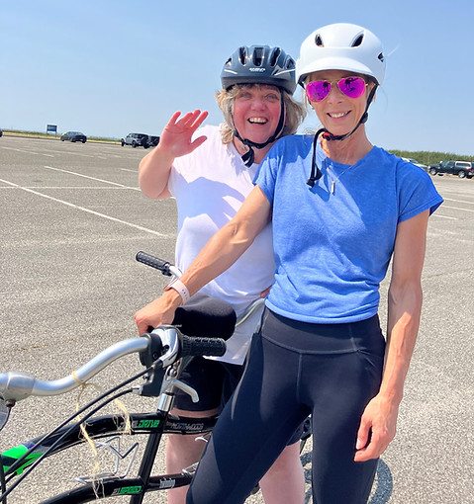

**The Other Side  
Written by Judy Wieber and Ryan Criscione**

Meet our new TRAID Director, Ryan Criscione. Ryan has been working for SILO since 2020. She started out working in the Regional Resource Development Center as an Administrative Assistant, then a Nursing Home Transition and Diversion Waiver Specialist and then Lead Specialist within the Regional Resource Development Center. She is now responsible for the Technology-Related Assistance for Individuals with Disabilities (TRAID) Program. SILO is one of 12 TRAID Centers throughout the state of New York. It is a federally funded program through the Department of Justice and it’s aim is to make assistive technology more attainable for people with disabilities.  SILO is supplying informational resources, demonstrations, referrals, and loans.

What makes Ryan a good fit for this position is her personal experience and compassion she has for people using the technology. She understands the importance and need from her mom. Ryan's Mom was diagnosed with Multiple Sclerosis when Ryan was three years old. The following are some of her personal reflections as an adult growing up with a parent with a disability.

​

*When introducing people to my parents for the first time, I have learned that a, “Oh, by the way, my mom is in a wheelchair,” is a good heads-up. To me, I don’t see the disabled woman in a wheelchair. I see my mom. The one that taught me colors, numbers, how to read, that with a cup of tea and a good hair day, anything is possible. I have a whole speech I give; the general information is that we don’t want a pity party. There is no reason to feel bad for us. There are the usual phrases thrown out like “You are an amazing daughter to help. Not everyone has that.”  Which I never know how to respond to. Just like everything else in life, growing up with a parent with a disability has its difficulties.*

​

*From the other side of the wheelchair, there are great life lessons and a wide range of emotions. There are feelings of selfishness for not wanting to help and to just sleep late, guilt for feeling like that, and then thoughts that you are a horrible person. I have learned that caregiver burn out is real and sometimes its okay to feel like that. Its human to feel like that. Quite frankly, I would be shocked if not everyone felt that at some point. But it is not a constant feeling in my life. As much as she does not believe it, my mother is not a burden. When someone asks me about my mom, burden, is not a thought. Nothing about her disability is a thought. I tell them how tough she is, how she is the most stubborn person I have ever met. That besides the tenacity, she is kind. That having her as a mother has made me better.*

*​*

*There is a butterfly effect from having a family member with a disability. I am a better person because of it. I don’t hesitate to ask someone if they need help, to hold the door open to a store.  I got to see my kids’ faces light up with pride when they were old enough to help push grandma. My kids are better people because of my mother’s disability. I have received so many compliments on how my children have treated other children with disabilities. That they don’t “see” other peoples’ disabilities.  I know that as they finish out their teens and become adults that that will stay with them. As they grow up and have their own family that their kids will do the same. That my mother had made this world a kinder place*

*.*

To learn more about the TRAID program contact Ryan at: (631) 880-7929 ext. 168, Fax: (631) 946-6377, or e-mail: [rcriscione@siloinc.org](mailto:rcriscione@siloinc.org).

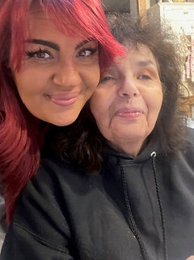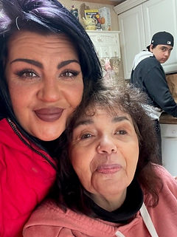

**Welcome Abdul Jangda  
Written by Judy Wieber**

Welcome Abdul Jangda, one of SILO’S recent hires, receiving On-the-Job-Training at SILO. Abdul is learning what it takes to be a member of the SILO Information and Technology (IT) Team under the direction of Oscar Salgado. Access VR, together with SILO’S Independent Living Center, and funding from New York State Department of Education are making it possible for Abdul to be given ample opportunities, learning the specific skills required to work in the field of I.T.

Presently, Abdul is pursuing a dual master’s degree from New York Institute of Technology in Cyber Security, and Information Technology.  His vocational goal is to secure a permanent supervisory position in one of these areas.

Abdul graduated from Farmingdale University in 2022 with a B.S. degree in Computer Programming and Information Systems. He also obtained in 2019 an A.S. degree from Suffolk Community College in Information Technology: Network Design and Administration. Some of Abdul’s previous work experience includes supervising Farmingdale University’s computer Lab, as well as an Office Assistant in the International Student Office. He completed an internship at Stony Brook Medicine in the Administrative Systems Department.

What is even more impressive is that Abdul completed all this extensive coursework and experience as a student with a disability.  Abdul is a person whose disability is a hidden one.  Many see him and do not realize that he is dealing with fatigue and an inability to sit or stand for long periods of time.  He utilizes the use of power tools because his condition makes it difficult to use manual ones. At times I.T. work can require getting down on the ground, another difficulty due to his condition. However, this challenge is worked around by utilizing a low to the ground seat. A seat he can better maneuver in and out of, from the floor to a standing position.

Access VR’s On-the Job-Training allows perspective employees with disabilities the chance to figure out and ask for accommodations to see what may work best for a person before that permanent position becomes available.  It enables a person to go into the next interview with confidence and knowledge of how to work around a challenge a disability may cause to perform a certain work task.  It allows you to know how one is going to work around a potential problem before getting in front of the interviewer, while still gaining skills and practical techniques of the trade.

On-the Job-Training is a win-win situation. Businesses receive highly knowledgeable employees, and potential employees are paid while receiving specific skills and opportunities to adapt to real life work scenarios.

The following are some thoughts shared by Brian Garcia, regarding Abdul as a student at Farmingdale State College: “As Director of the TRIO Student Support Services program at Farmingdale State College, I have known Abdul for about four years. Abdul has made an indelible impression as a program member by demonstrating extraordinary work ethic and leadership potential. Abdul possesses a number of impressive strengths that would serve as an asset to the IT staff. One strength that particularly distinguishes Abdul is his relentless pursuit for self-betterment. He is one of the most persistent individuals I have ever met and was revered among TRIO staff as well as his peers.”

The Trio Student Support Services program is a program funded by the New York State Department of Education. It serves first generation college students with economic need, as well as students with disabilities. Only 185 students are selected for the program each year.

The best of luck to you, Abdul. It sounds as though you will be an asset to our Information Technology Team.

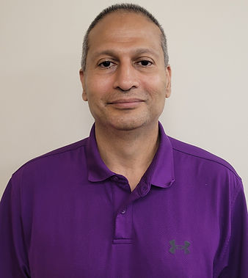

**Meet our Self-Advocacy Conference Speakers  
Written by Judy Wieber**

When looking at the line-up of keynote speakers at the Self-Advocacy Conference scheduled for October 13, 2023; one would agree that SILO has put together the “A” Team for tackling employment issues plaguing young and old New Yorkers with disabilities. Kimberly Hill, the first Chief Disability Officer of New York (presenting virtually), and Dr. Christopher Rosa, earlier Assistant Vice Chancellor for student Inclusion Initiatives CUNY, now CEO and President of The Viscardi Center and President of Henry Viscardi School.

Kimberly Hill is a graduate of Utica College of Syracuse University and a resident of Latham, NY. She started out as a writer for the Assembly’s Communication and Information Services Department, and then held the position of Director of the Assembly’s Task Force on People with Disabilities. As the director, she coordinated 24 Disability Awareness Days and worked to pass bills related to NYS’s Medicaid Buy-in and the Nursing Home Transition and Diversion Waiver. Prior to being the first Chief Disability Officer, she had served as the principal analyst with the Assembly’s Standing Committee for People with Disabilities.

It has been reported that 30 percent of New Yorkers with disabilities are living at poverty level, and that only 35% of working aged persons with disabilities are gainfully employed. Kimberly Hill hopes to combat these statistics by creating 1,200 new state agency jobs for prospective employees with disabilities.

Dr. Rosa was born, raised and lives in Flushing, Queens. He received a PhD. in Sociology from CUNY Graduate Center in 2001, and a BA of Sociology and Philosophy from Queens College in 1989. Dr. Rosa, prior to accepting his present-day position, worked for 28 years at Queens College CUNY, improving and leveling the playing field for students with disabilities.

Dr. Rosa has been noted as saying: There hasn’t been enough consistent investment by the state in infrastructure, and capacity to ensure that college students with disabilities have equal access to all programs and curricula. Not enough is being done to ensure they are becoming ready for transitioning from college to the world of work.

I believe Dr. Rosa will and has already proven what it takes to turn things around for young people with disabilities. He is dedicated to giving ample opportunities for his students to grow and excel. Whether it is making sure student athletes are provided the resources to achieve, or students are encouraged to write for their school's newspaper, Dr. Rosa is the right person in their corner, cultivating an environment of community and students with disability culture. Keep our eyes and ears focused on the Viscardi Center and Henry Viscardi School as an excellent example of how to support and guide the new generation of young people with disabilities.

[Register for our 2023 Self-Advocacy Conference](https://www.siloinc.org/selfadvocacyconference" \t "_self)

[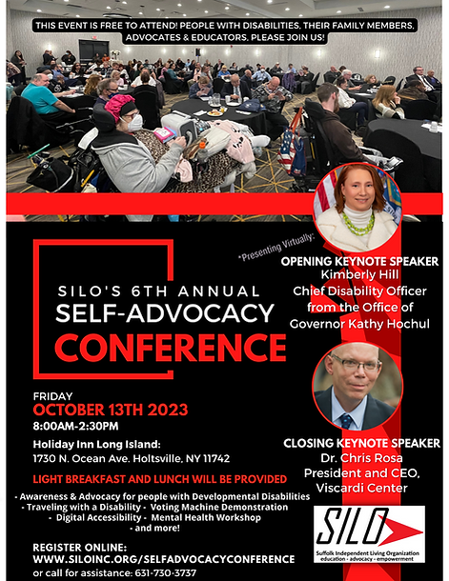](https://www.siloinc.org/selfadvocacyconference)

**September was National Recovery Month for Mental Health and Addiction  
Written by Judy Wieber**

As SILO awaits the opening of our new mental health clinic, SILO Staff join Councilman Jonathan Kornreich and the Town of Brookhaven, commemorating the month of September as National Recovery Month for mental health and addiction. All staff were encouraged to wear the color purple on September 6th, showing our solidarity for all going through the recovery process. The hope is that our sea of purple will send forth a wave of strength and empowerment to all those faced with the challenges of recovery.

