**APRIL NEWSLETTER**

## Judith Heumann Written by Judy Wieber

I cannot think of a more appropriate way to celebrate the month of March, Women’s History Month, than to pay tribute to the mother of the Independent Living Movement, Judy Heumann.

Sadly, Judith Heumann passed away on Saturday, March 4th, at the age of 75, leaving behind a legacy of social change. Her work will not soon be forgotten by the millions of people around the world living with disabilities. She left this world a little nicer than the way she found it.

Full of chutzpah, a gift given to her from her mom, and her “New York attitude” had come to serve her well. She beat the New York City Board of Education in a discrimination case after they refused to hire her as a teacher. She staged numerous “Disability in Action” demonstrations in the 1970s.

Some of the demonstrations she helped to lead and organize involved groups of people with disabilities blocking four-way intersections in downtown Manhattan, interrupting the flow of traffic, as well as, 8 nation-wide rallies, and sit-ins demonstrating the importance of the need for prompt regulations to section 504 of the Rehabilitation Act of 1974.

Ed Roberts, known for being the “Father of the Independent Living Movement,” hand-picked Ms. Heumann, to help him establish the first Independent Living Center in Berkely California. The home place of Heumann’s Alma Mata, Berkely University, where she received a Masters of Science, in Public Health.

​

One of the more powerful and memorable demonstrations was a 26 day “sit-in,” where nearly 200 folks with varying kinds of disabilities, banded together and remained on the fourth floor of the federal building in San Francisco. This is where the Health, Education and Welfare Agency was located. The demonstrators remained until the Carter administration signed the regulations of section 504 in April of 1977. She brought protest to the Reagan Administration when they proposed cutbacks to services.

She could also be seen addressing senators in 1990 at the “Capital Crawl,” which led to the passing of the Americans with Disabilities Act. Her passing prompted me to view the 2021 nominated Academy award documentary: “Crip Camp” for which Judy Heumann played a key role. The film was produced by the production company Higher Ground, owned by President Barack and First Lady Michelle Obama.

It is here at Jened that she makes lifelong bonds and fellowship with her strong spirited cohorts. The documentary is immensely powerful and poignant. It is an excellent way to educate the community on the history of the movement and the feelings of young people with disabilities, especially during the 60s and 70s. They had developed a kinship and feelings of "normalness” that they had never felt before, which gave them the confidence to go back to their home communities and light the way.

Judy Heumann held positions, under both the Clinton and Obama Administration. She was instrumental in getting many important pieces of legislation passed. President Obama appointed her as the first Special Advisor on Disability Rights.  She was an author and had her own podcast.

I, for one, wish I got to meet her in person. As in the words of Elton John: “I would have liked to have known you, but I was just a kid. The candle burned out long before the legend . . .”  (Ever will).  I want to thank you for the trail you blazed and the path I use my white cane to trail along.

## Easter Oreo Bark Written by Jill Cuyar

While looking for a fun Spring recipe to include in this month’s newsletter, I reached out to a former director at SILO, Lori Corrar, since she always makes the most creative baked goods. She sent me an “Easter Oreo Bark” recipe from Pinterest that is no-bake and takes 5 minutes to make!

Ingredients:

1 container of (festive) candy sprinkles- optional

10-12oz white chocolate chips

About 4 Oreos (crushed)

½ cup pastel color M&Ms

Instructions:

1. Line baking pan with parchment paper or foil
2. Melt white chocolate in the microwave (or a pot if you do not have a microwave)
3. Pour white chocolate into prepared pan
4. Sprinkle M&M’s and chopped Oreo pieces on top of the white chocolate and press down slightly so the stay put when the chocolate hardens
5. Finish with candy sprinkles
6. Let harden (Place in freezer for 10 minutes or refrigerator for 30-60 minutes)
7. Break bark into pieces with your hand or cut with a warm knife

Now you have a fun, sweet Spring treat!

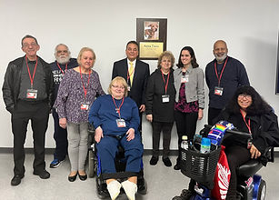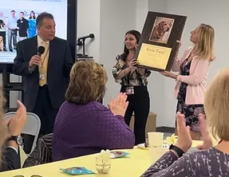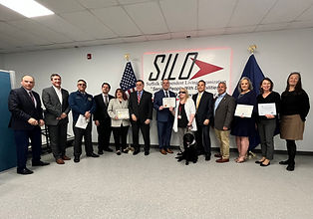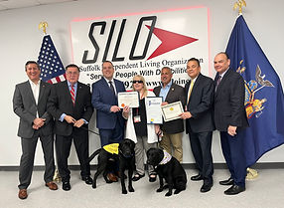

March 23rd 2023: Local officials and community supporters come together to dedicate SILO's Community Room to Anna, former guide dog of Marilyn Tucci

**Anna  
Written by Judy Wieber**

On March 14th, 2007, Anna was born. Marilyn Dog, a yellow Labrador, and Clover, a Golden Retriever, gave birth to a Golden Lab cross, one of nine puppies in the litter.

Anna, though a cross, looked more like a Yellow Lab, bred with a special job in mind. She would grow up to be a guide dog for a continually active disability rights advocate, Mom, and Grandma, SILO’S own Marilyn Tucci.

Marilyn Tucci worked with Anna for ten and a half years, traveling by planes, buses, and ferries.

Marilyn credits Anna for being the longest working guide dog at SILO. She took Marilyn to many places with her children, husband, and friends. In fact, Marilyn remembers the fun time she had on two separate trips to Orlando. One trip she took with her husband, and another she went to “Top Dog Workshop,” a guide dog convention, with fellow friends and guide dog users.

Trips to shopping centers, schools, state and county legislatures, work, movie theaters, beauty salons and restaurants were all accomplished. Marilyn recalls several out of state trips, many to Florida, North Carolina, Georgia, Virginia, Pennsylvania, New Jersey, Connecticut, and Rhode Island. On a trip to Georgia, they got to meet the very generous Puppy Raiser family, who first taught Anna puppy manners. Anna is one of five guide dogs Marilyn has handled. “She was a very hard-working guide and very special to me as all my guides were very special.”

Anna passed away on January 27, 2020, at the age of twelve and a half.  Marilyn wants to thank our CEO, Joe Delgado for dedicating and naming SILO’S community room, “Anna’s Room” in her memory, and in recognition of all the challenging work guide dog teams do to promote safety and independent living of the blind.

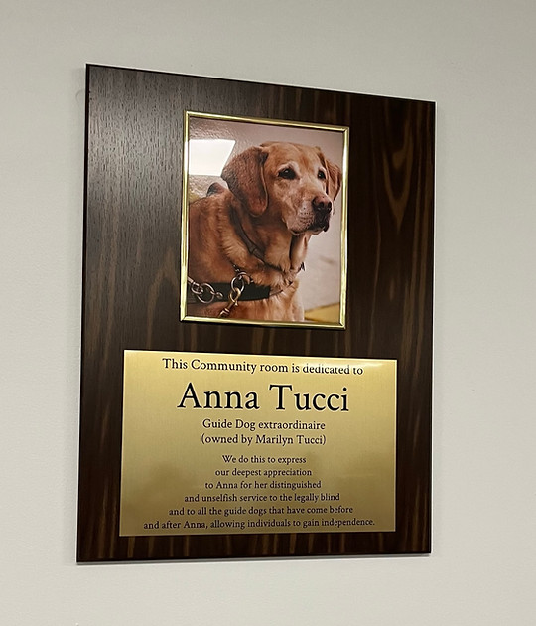

## April is Autism Awareness Month Written by Judy Wieber

Since my disability is blindness. I decided to do something to heighten my awareness of families living with Autism.

I read the book: Chicken Soup for the Soul - Raising Kids on the Spectrum, 101 inspirational stories for parents of Children with Autism Asperger’s.

​

One reason I, and others love these Chicken Soup for the Soul books, is the way they present the subject with a collage of short stories, mirroring real life that touch your heart and widen your own life experiences, in hopes to educate.  The stories seem to highlight and capture the realism of life. They are honest, attempting not to cover reality up, but rather the book presents the truth, the challenges and the joys in a way that moves the reader to a better understanding in a very relatable way. Do yourself a favor this month and check it out, families living with someone with autism will thank you.

**SILO Donates Track Suits to the Special Olympics *American Muscle* Athletes & Coaches**

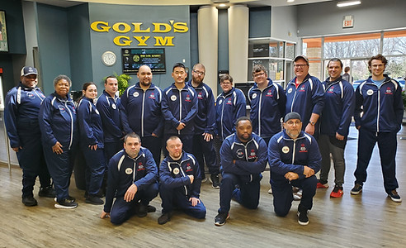

**Greg Runfola- PIP Outreach Specialist  
Written by Judy Wieber**

I would like to introduce Greg Runfola, SILO’S own Peer Integration Program Specialist.  Greg has been with SILO now for three years. When Greg is not at SILO, he can be found practicing, teaching his Brazilian Jiu Jitsu skills, or volunteering as a powerlifting coach for “American Muscle" team.

​

I think it is great that you are coaching the Special Olympic power lifting team.  You mentioned just starting with them, how did you get involved?

​

*My sister was in the Special Olympic Games when I was in elementary school, which is where I was first introduced to the event.  I recently started community habilitation with an athlete who competes on the Special Olympic Softball team.  While attending one of his games, I heard the head coach mention he also runs the powerlifting program.  (I would come to find that Coach Warren, and his wife Edna, run most of the Special Olympic (SO) teams in Suffolk County).  When the softball game concluded, I asked Coach Warren if I could volunteer when the powerlifting season starts. I am proud to say, that Mr. Fletcher recently appointed me as a coach- right before our first competition.*

Did you have a special interest in powerlifting, or is that where they needed a coach?

*I would only want to coach sports that I feel I would be of value to- both for the program and its athletes.  As far as an interest in powerlifting, over the last ten years, I have had the privilege of training under Dr. Pat Davidson, a renowned exercise physiologist, and over time, a good friend.  I have trained with him in academia, in gyms he designed with specialized equipment.  Although I have never competed in powerlifting, I have had access to the absolute highest levels of strength training.  Dr. Davidson has run clinics with professional baseball and basketball teams, the latter being the defending world champions.  I am highly motivated in making such training available to the American Muscle Team.*

​

You mentioned the Gold’s Gym, which town do they train?

*The Gold’s Gym is in Smithtown.  The ownership at Gold’s have not only made their facility available, but they have also embodied the principles of the Special Olympics. Meaning, they have fostered an environment of acceptance, an ecosystem where our athletes are included. I knew I had been blessed with this team when I witnessed the patrons at the gym stop their workouts to cheer athletes when they were completing a difficult lift.  It is a privilege to experience what the staff at Gold’s and coach Fletcher have created for the athletes.*

 Are you the guy responsible for obtaining SILO’s sponsorship?

*The only thing I would be responsible for is connecting SILO to the head coaches, Edna and Warren Fletcher.*

*Mr. Delgado has been graciously supportive since he was introduced to the team. Without hesitation, he offered SILO’s sponsorship and was enthusiastic to offer the organization’s assistance and expertise.  Laurie has been diligently working with the coaching staff to obtain the team’s warmup gear.  It was Mrs. Delgado’s idea to add the embroidery, making each suit unique to the individual athlete.*

I know the Olympics have the five rings, what does the Special Olympics use as a Logo?

*The only fact I know about the logo is, the 5 figures represent the 5 original countries that participated in the games.  I did however recently learn their motto, which I think we all can appreciate,*

*“Let me win. But if I cannot win, let me brave in the attempt”*

*One of the team’s standout lifters wrote it on a fogged out bus window, while on our way to the first competition… "fight the good fight."*

*​*

*Even though it is a powerlifting team, the lifts are done individually.  In my experience, doing anything alone in front of an audience, requires courage- no matter what population it is being requested of.  Ultimately, powerlifting is a sport where you do your best to not fail, while on a stage.  A lift that isn’t counted in competition is literally called a failed lift.  In spite of it all, I can confidently say, the athletes on the powerlifting team carry themselves with more sportsmanship than many of the competitors I have known.*

You mentioned being a lifeguard and a personal trainer, is this your first time training persons with a disability?

*When I was a personal trainer in the city, I had a client, Al Roker.  He had a disability of cancelling often and forgetting to pay.  I was not successful in making helpful adaptations to his individualized training program.*

*​*

*However, I have created successful adaptive BJJ (Brazilian Jiu Jitsu) programs in the city and on the island.*

How many are on the team?

​

*We have around 15 athletes*

Is everybody from LI?

*The Special Olympics are broken up into regions.  Our team, “American Muscle” are the sole representatives for Suffolk County.*

When and where will the World Competition take place?

*To my understanding, the world competition will be held this June in Germany. I understand Edna and Warren’s son, Daniel, one of the team’s strongest athletes, bench presses more than 200 pounds and dead lifts 347. Daniel recently participated in the polar plunge in November of 2022, here on Long Island. The polar plunge is one of the biggest annual fundraisers for the Special Olympics. In fact, the “Freezin’ for a Reason” raised $130,000.00 this year.*

If someone still wanted to make a monetary donation, would you know where one would send it?

*Yes, contact the following link:* [*https://www.specialolympics.org/get-involved/donate?locale=en*](https://www.specialolympics.org/get-involved/donate?locale=en)

## Some interesting articles relating to advocacy and inclusion of people with disabilities...

The American Council of the Blind and Supporters Rally to Demand Accessible and Inclusive Currency:

[*https://www.prnewswire.com/news-releases/the-american-council-of-the-blind-and-supporters-rally-to-demand-accessible-and-inclusive-currency-301771930.html*](https://www.prnewswire.com/news-releases/the-american-council-of-the-blind-and-supporters-rally-to-demand-accessible-and-inclusive-currency-301771930.html)

​

An Adaptive Fashion Brand Makes Its Mark at London Fashion Week:

[*https://nowthisnews.com/news/unhidden-adaptive-fashion-brand-shows-at-london-fashion-week?&utm_medium=social&utm_source=Facebook&utm_campaign=nowthisnews&fbclid=IwAR2Dqew-jxS3TQbJUUrN75TyLgQwBbCiVXKXOXqXGprYQvjcn6u3wrhewDE*](https://nowthisnews.com/news/unhidden-adaptive-fashion-brand-shows-at-london-fashion-week?&utm_medium=social&utm_source=Facebook&utm_campaign=nowthisnews&fbclid=IwAR2Dqew-jxS3TQbJUUrN75TyLgQwBbCiVXKXOXqXGprYQvjcn6u3wrhewDE)

Advocates want Medicaid cuts to home care eligibility blocked in budget:

[*https://spectrumlocalnews.com/nys/central-ny/politics/2023/03/08/advocates-want-medicaid-cuts-to-home-care-eligibility-blocked-in-budget?cid=share_clip*](https://spectrumlocalnews.com/nys/central-ny/politics/2023/03/08/advocates-want-medicaid-cuts-to-home-care-eligibility-blocked-in-budget?cid=share_clip)

## The Stars Were in Alignment Written by Judy Wieber

Allow me a moment to relive a memory with you.

Back in 2010, my husband and I had bought tickets to see JoDee Messina and Brad Paisley in concert.

Harold was the biggest Country Western fan on the planet.  He loved Rascal Flats, Martina McBride, Tim McGraw, Sheryl Crow, Brad Paisley, Jo Dee Messina, the list went on.

He was working for National Grid full time as a collection’s representative, and I was home with our kids.  We were both para transit users, homeowners, and parents.

The concert sounded great. Country’s lyrics can teleport you to another place and time. Needing a break from the stresses of life, we were looking forward to the show.  We thought, wow, a night out, date night. We really hadn’t been to a concert since before Hayden, our oldest child, was born. He was eight, and Maredith was 4 at the time.

Getting the tickets was the easy part, scheduling our transportation was the challenge. Since we were living in West Babylon and the concert was in Westbury, this meant traveling from Suffolk into Nassau, not an easy task; but we really wanted to go.

We thought out our options. Hmm? I could ask my parents to babysit, that was no problem. They loved any chance to be with the kids. Babysitting for us, cross them off the list for a ride. Then we thought, how about Patty, Harold’s sister?  No good. She had to work. My brother? Nope he would be out of town. Hmm? I know. “SCAT and ABLE Ride, the para- transit system?!”  “Are you kidding?” Harold said. The concert will not be over until 9:30 pm and you know how SCAT only runs until 8:30 pm. “How will that ever work?”

He was correct.  SCAT only operated until 8:30pm.

“I got an idea.” The concert starts at 7pm We can give ourselves plenty of time. Take SCAT to the Walt Whitman Mall, transfer to Able Ride, then on the way home, we can take ABLE Ride from Westbury Music Fair to the LIRR to Babylon station.

It was a plan. Everything was a go. ABLE Ride ran much later than SCAT and we could get a late train from Massapequa to Babylon.

Keeping our fingers crossed, we prayed there would be no hang ups with transferring. Able’s window differed from SCATS. In Nassau, the pickup window starts right at your reservation time, where SCAT’s starts 15 minutes before your scheduled pick up.  In Nassau, they only give you a five-minute grace period. If you are not there, the bus will leave without you. We were early for Able ride and arrived early for the show.

Heavy rain was predicted for later, but we were ready, umbrellas in hand. First part of the journey went like clockwork. Now, we made our way from the bus to the doors of the venue. Going inside, we waited for the ticket booth to open. Slowly the crowds of people filled the lobby. We stood off to the side waiting our turn. I believe we must have waited a good forty-five minutes. Believe it or not we must have had about four different people come up to us, letting us know they recognized us from somewhere, or they knew a co-worker of ours.  People were at the ready to offer an elbow to the ticket booth.  An usher showed us to our seats.

The show got under way late, as a result, we had to leave unfortunately before the end, if we wanted to catch our return trip to the train. The show was great, and we hated to leave, but we knew we better.  As we approached the exit door, we could hear it was teeming, raining cats and dogs. Shoot, we had left our umbrellas back inside.  What to do?  We would never find our seats without assistance, and there was no one in ear shot.   plus, we would run the risk of missing our bus.  If we stood outside and listened for the bus, we would get drenched.

We decided to stay just inside the doors and hope we would hear the bus from where we were standing.   About thirty minutes later, a security guard asked if we were waiting for a para transit bus.  Yes, Harold said.  “Well, it just pulled away.” We missed it.  Now what would we do?  It was raining heavily and no ride.  But it was okay because we had each other, and we held each other’s hand while we tried to figure things out.

Take a cab from the music fare to the train?  I suppose that might have been an option, but one, we really did not want to have to pay the price.

Now the concert was over.  Crowds of people walked by us.  Harold was just about to give ABLE Ride a call when the people we sat next too in the row approached us, asking if we left our umbrella inside.  Wow, great, yes thank you. At least now we would not have to stand up on the train platform in the rain without the protection of the umbrellas.

Harold placed the call and explained how we must have missed the bus, and would they be able to send the driver back to pick us up?  The gentleman overhearing Harold interrupted him and asked, “can my wife and I give you and your wife a ride home?” A ride?  Holy smokes.  This did not happen every day.  Now, we do not know the people, but they seemed nice and trustworthy.  Harold sounding relieved said, “Sure, thank you.”   I on the other hand, confident in our ability to do this on our own, and not too sure we should get into a car of people we did not know, squeezed his hand.  If I could have, I would have shot him a look, saying: “Are you kidding? We do not know these people!”  I have a feeling that is exactly what my face was saying. Harold whispered, “Do not worry, it will be ok.”  Being a trusting wife, I trusted his judgement.

The fellow concert goers guided us to their car.  It was a SUV.  Though you know that little voice inside your head, that says, “stranger danger, do you really think this is a good idea?” kept playing in my head. As I put my hand inside the vehicle, I found a child’s car seat.   I thought to myself, they are parents, and they returned our umbrellas, and they are Brad Paisley fans.  Harold is a big guy, and my protector, it will be okay.

I slide inside, shutting the car door behind me.  There was no turning back.  Everyone was in and the driver says, “I just want to thank the two of you for letting us drive you.  After all, you do not know, we could be serial killers.  He then locks the car doors.”  My heart started pounding very quickly.  There was an uncomfortable silence.  Then we all let out a big laugh. I really did not think that was funny.

As we talked with the nice couple from Ronkonkoma, I learned that we had an actual connection; Their daughter went to school with my God son, Michael.

Wow, that had to be the fifth person we came across at this concert where we had some kind of connection.  That truly never happens.  They say there is only six degrees of separation, and the stars must have been in the right alignment.

The entire story sounds like a big ordeal from scheduling trips, to finding our way back and forth. we Were young and adventurous. I guess it goes to show, where there is a will, there is a way.

Unfortunately, it is thirteen years later and Nassau County’s NICE Bus runs around the clock, where Suffolk County closes up at 8:15 p.m./ 8:30 p.m.

Even if the concert was in Suffolk today, we would have still needed to either go home early, or find a family member or friend, nice passerby (highly not recommended) or pay the extremely high cab fare to get to a train, or just not go.  Now, not going is not fun, but taking a SCAT ride would be the preferred choice for an independent night out.

Let Suffolk County know that people who are disabled can have a life after 8 p.m.