**December Newsletter 2023**

**Advocacy and Empowerment Team**

Written by Judy Wieber

SILO is proud to announce Marilyn Tucci has been promoted to Director of the Empowerment Advocacy Department. Marilyn will lead a staff of four SILO employees, along with several volunteers, who will be working on critical issues facing our community.

Three issues the department is working on during December are: Transportation, telephone access for people living in nursing homes, and the accessibility of our parks and beaches.

Did you know that SCAT is now running until 10pm, Monday through Friday, and until 9pm on Saturday, and 8pm on Sunday? If you knew, consider yourself lucky. Here, many of us have been advocating for years to have extended service; the extended service was granted, yet no one knew the later times became effective October 29, 2023. It is the biggest kept secret, why? Is it that SCAT and the County do not want us to know, so they have a reason to take it back?

If you want to keep the extended hours alive, and this is a matter that concerns you, call and make a late return. Better yet, volunteer, join Marilyn, have an impact on the services that affect you most living on Long Island.

Did you know over 100,000 New York residents live in a nursing home, according to the New York State Department of Health. In Suffolk County, there are approximately 57 nursing facilities, yet most deny their residents access to phone calls out of the local area. When so much has been reported on - a person’s health improves when people stay connected with family and friends, why are nursing homes not allowing residents to call out of the area whenever they wish.

Marilyn and her team of advocates are diligently trying to get bill S4242 out of the Health Care Committee in the New York Senate, where it presently sits, for it to become legislation.

S4242 is a bill which will requires all nursing homes to provide their residents with telephones in everyone’s room that can make both local and out of the area code phone calls.

People living in nursing homes make up about 15% of New York’s population. All residents have disabling conditions. They are all members of our community. Our legislators and representatives need to hear from us about this important matter. We need to speak up for nursing home residents as one community of people with disabilities. Let it be known that long distant phone calls are necessary. If you want to help this bill to become a law, volunteer and contact Marilyn and her crew.

Have there been times you wanted to go to a local park, or beach, only to be greeted with more obstacles to beauty and relaxation once you reach the beach, or park?

Contact Marilyn and her team and find out what we can do together to voice our concerns. 631-880-7929 x125

[**Flower Pumpkin Muffins  
Link for a great holiday recipe!**](https://walkingonsunshinerecipes.com/mini-pumpkin-pie/#mv-creation-255): <https://walkingonsunshinerecipes.com/mini-pumpkin-pie/#mv-creation-255>

**International Day of Persons with Disabilities**

Written by Judy Wieber

On December 3, 2023, we celebrate and acknowledge International Day of Persons with Disabilities.

In honor of this day, I would like to highlight a recent workshop held at the Self Advocacy Conference hosted by SILO on October 13th of this year.

It was a workshop held by Michael Caprara of the Viscardi Center. The workshop, entitled: “Digital Accessibility” spoke of how the Viscardi Center is helping to create an accessible Digital world by supplying digital access services to businesses, organizations, and individuals worldwide. They are supplying document accessibility, website accessibility, captioning services, and descriptive narration. They test websites, documents, and events for legal compliance with the ADA section 508 and Website Content Access Guidelines 2.1. If it is found to be noncompliant, they can reconstruct and build avenues to accessing the digital information from the onset of the document, website, pdf, PowerPoint, spreadsheet, table, etc. As more come to learn of their services, the hope is that occupational manuals, job applications, employee handbooks, learning materials used in the workplace, and universities, will be ready and available as employees and students with disabilities are hired and prepare to learn.

​

In fact, one of the conference participants reached out to Michael at the conference to make an accessible flyer advertising a Dinner in the Dark event, where in turn, the flyer could then be loaded up on a website where all could access the information, regardless of one’s disabling condition.

Hats off to SILO and the Viscardi Center for educating and empowering, to change inequality.

**The following are two testimonials provided by Marilyn Tucci and Judy Wieber regarding their voting experiences in November 2023.**

**Submitted by Marilyn Tucci:**

On Saturday, Nov 4th, I went to early voting. My friend went with me as in early voting, you can go to any poll sight in your township. We arrived at 11:30. the polling place was open at 10. After signing, I was showed where the Dominion IMAGECAST Evolution (ICE) machine was. I was asked many times if I knew how to use it. I stated “Yes, I have been using the accessible voting machines for years.” It was facing the wrong way and asked them twice to please turn the machine around facing the wall, so I have privacy. They then set up the input device and gave me the headphones. I asked for the paper that goes on the earpiece. They said they were not sent any. I said this is for sanitary reasons in case someone has an ear infection. The woman said these are new headphones. You are the first to use them. I stated what if other people are going to use these after me? She said we have a lot of new head sets to give people. So that means all week long anyone using the headset was given a new set of headphones? I preceded to vote and then checked my ballot to make sure I voted correctly for the politicians and proposal on the back. It read it back to me, so I preceded to print out the ballot. Then I got an error message. The woman came over to the machine and looked at it. She then got the ballot out and looked at it. Nothing printed out. She said something was wrong with the machine. She did not know what, but I was told it worked fine all week long when others used it. She then offered a Democrat and a Republican to help me vote. I told her no. That is taking away my right to privacy and independence for two people to see how I vote. I had to ask my friend to vote for me as I told her for whom I was voting. Again, my right to privacy and independence was taken away.

**Judy Wieber submitted the following testimonial:**

I have been using the Dominion IMAGECAST Evolution (ICE) Machine to cast my vote since 2010 when New York State went to electronic voting. Every year my experience has been the same: the machine must be taken out of the box and set up, and poll workers have no idea how to get it working.

In 2021, the machine skewed my ballot and I had to have someone aid me with my vote. This annoyed me to no end.

It annoyed me so much, I decided to vote in “early voting” in 2022. At that time, “early voting” for me, was being held at the Town of Babylon Annex in North Babylon. That was the most pleasant voting experience I have had to date. The machine was ready to be used and the poll worker understood what I was talking about when I asked for the BMD machine. I had a question, and the worker knew how to resolve the problem.

This year, I decided to go back to my polling place in West Babylon. Here too, I had a semi-positive voting experience. The machine was ready for me to use and though the poll worker was not familiar with the machine, she did figure things out quickly. I was able to vote in under an hour, in contrast to three hours in years past.

My only concern about this years’ experience was the attitude of the poll worker. When I first mentioned the BMD machine, she was not sure she would be permitted to use it. I am not sure why she felt this way since it was there for people with disabilities. In fact, anyone can use the machine. It is used to cast anyone’s vote, if say one of the other casting machines are not working properly. She did have to make a few phone calls to figure out how to use it, and she tried to convince me to have someone aid me instead. I politely explained that many people, including myself, had advocated for the right to vote independently and privately. After the calls were made, and my ballot was prepared in the machine, I voted. I voted privately and independently.

When I got home that evening, my 20-year-old son shook his head and said: “Ma, I do not understand why you get so upset with things like this. Maredith would have helped you.” My response to this was: “Yes, Hayden, Maredith would have helped me, but it would have been a step backwards in the independent living movement.” If all Americans have the right to pursue life, liberty, and happiness, then I too should be able to do this as well.” If we are told someone can assist our voting, then what will stop someone from telling me: you do not need to pursue a means of making an income independently, or buying a home, etc. All people should have the right to think and do for themselves if one is capable to do so. My eyes are not capable of reading a voting ballot, but we have the technology that will read the ballot for me and others who have this same difficulty. When equipment is not installed, when poll workers are not trained properly, and when attitudes of poll workers serve as barriers promoting discouragement, injustices are done. It says: “We do not care about you, or the population of people you represent.”

Independence improves a person’s quality of life. If the technology is there, it should be understood, and kept. The want to be independent is what motivated us Americans to become a new nation, formed to think and live in a democratic society.

If I had held my tongue, and not politely held my ground, I would have felt defeated. Instead, I left my polling place with my head held high, getting a few pats on my back, encouraged and hopeful about tomorrow.

What was your voting experience like? We here at the newsletter would like to know.

**Dinner in the Dark**

Written by Judy Wieber

On Sunday, October 22nd, I attended Dinner in the Dark, hosted by Visually Impaired Persons of Suffolk (VIPS). Honored to be seated at the SILO sponsored table, I enjoyed the evening which was filled with encouragement and gratitude. Raising the awareness of the struggles facing the low vision community and the skills learned to overcome these challenges, was the theme of the evening. The not-for-profit’s membership and organizing board consists solely of people who are either blind or visually impaired, described as: “For the blind, by the blind.” The mission of the support group is to stand up against discrimination, provide peer support, and to plan recreational social events such as: holiday parties, trips to the movies, book clubs bowling trips, etc.

We heard from VIPS president, Meesha Johnson, and Chairman, Michael Jordan, speaking very dynamically regarding their own stories of transition. Michael spoke of how together, we can overcome anything, and the importance of letting our voices be heard.

Many people were honored with awards, including Marilyn Tucci, who was given a Lifetime Achievement Award for her many years of Outreach Advocacy and Solutions. Doug King’s wife, Erin, was also honored with an Outreach Advocacy and Solution award for the work she and Doug had done, to improve the quality of life for people with disabilities.

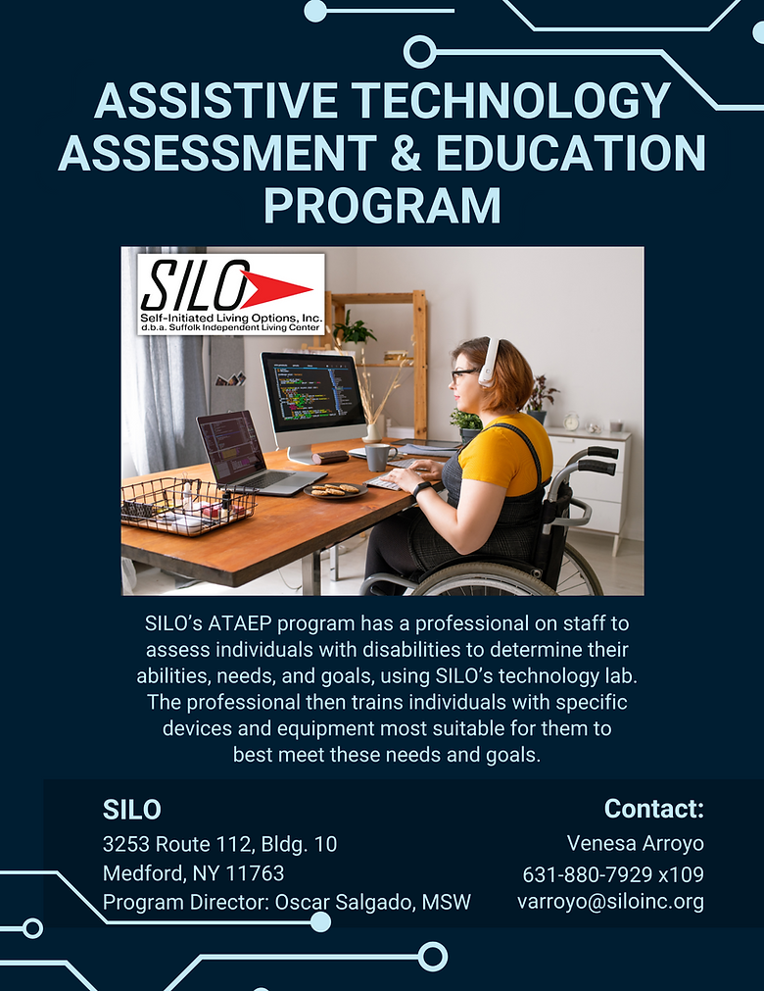

**Assistive Technology Assessment and Education Program**

Interview by Judy Wieber

In an effort to get the word out about the new Assistive Technology Assessment and Education Program and Assistive Technology Lab at SILO, the SILO Newsletter has decided to interview, Oscar Salgado, Director of A.T.A.E.P.

Judy: Who can the Assistive Lab service?

Oscar: We are here to support any individual with any disability, their family members, their aides/caregivers, our elderly population, and our veterans.

Judy: What is the mission of the Assistive Technology Lab?

Oscar: Our mission is a great one that strives to reflect SILO’s mission. We aim to increase, maintain, teach and improve the capabilities of those with disabilities with the use of technology. Often times, our participants are not even aware of what technology may be out there. So, with the help of SILO’s TRAID program, we can introduce them to these devices and train them on how to maximize their use in a personalized and one-on-one setting with the goal to help them retain or obtain a higher level of independence.

Judy: Does a person need to be evaluated for services?

Oscar: Yes, they do. The evaluation is done as a team effort with the participant being not only the main focus, but also the biggest contributor. The evaluation is the second biggest key component, second only to the participant themselves. The evaluation determines the person’s technologic needs in order to help them be successful not only in the workforce or educational setting, but also in their personal lives. Without the evaluation, it would be too difficult to pinpoint their exact needs and how to overcome their obstacles.

Judy: If a person with a disability is found to have a need for assistive technology in their life, how do they go about receiving the benefits of the lab?

Oscar: We are continuously working diligently on making this process as simple as possible. All the person has to do is call SILO at (631-880-7929) and speak with Venesa Arroyo, or email her at varroyo@siloinc.org. From there, I will contact the individual to schedule a time to meet in-person for an extensive hands-on evaluation.

Judy: Is there a charge for the services and what will be the cost?

Oscar: At the moment, if the person interested is not referred to us by ACCES-VR or NYS Commission for the Blind, the out-of-pocket cost would be $58/hr.

Judy: If there is a cost, who can a participant contact for financial assistance?

Oscar: We highly recommend that whoever is interested in this service call ACCES-VR. They will go through their process of assisting the person with building a detailed plan for employment. Once that takes place, they can then request to receive an evaluation for Assistive Technology. Not only would they have another resource when it comes to employment search and other services should they qualify, ACCES-VR will then send us a referral for our evaluation with a determined set of units (or hours) for training at no cost to the applicant/participant. People are also encouraged to contact the New York State Commission for the Blind as another potential resource.

Judy: Does a participant have to have a vocational need to access services, or if a person is in need for everyday living independence?

Oscar: This program although geared to help a participant be more successful in the workforce or educational setting, what we teach them is something that they can use in all facets of their lives. One of my favorite outcomes when working with a participant in this program is showing them what assistive technology devices and software are out there that they perhaps never knew of or didn’t consider.

We thank you Oscar for educating us on the new program.