**August Newsletter**

## Interview with Frank Krotschinsky Written by Judy Wieber

This past month I had the pleasure of interviewing Frank Krotschinsky, the Director of the Office for People with Disabilities. I found him to be quite interesting, a bit of a Renaissance man. Frank loves tinkering, caring for his car, traveling, reading books, playing with technology. Another hobby is his tropical fish which he enjoys. He has mechanical skills, taking care of his car’s maintenance. Being a professional has allowed him to own some of the specialized tools he uses to make the repairs that are needed. As a younger person, He would climb up on a picnic table, to get under the hood, or down on the ground to get himself under the car to do whatever needed to be done. NOT AN EASY FEAT FOR A PERSON USING A WHEELCHAIR. He loves to travel and hopes to get back to Germany to visit relatives, and to travel to Central America where his wife is from.

Frank moved to the United States when he was 8 years old. Recalling his mother’s words on the ride home from Kennedy Airport: “We will continue speaking German at home and you will learn English when you go to school.”  As a result, Frank is fluent in both languages. He also speaks some Spanish. His wife of 21 years, Maribel, is from Guatemala. His stepson, Dahlin, and daughter, Marcella, speak both Spanish and English. “Mirabel would speak Spanish to both children and they would answer in English.”

A proud Dad, happy to be attending his daughter’s junior high graduation ceremony this week. Seeing Marcella go through college is Frank's motivation for working as hard as he does. Humbly, Frank says, “I feel very blessed by the things and opportunities I have had in my life.  I am immensely proud of my family.”

Two people in Frank’s life who have influenced him the most are his 90-year-old uncle and his deceased grandmother. His uncle nearly lost his arm in a bicycle accident as a young boy. The injury cost him most of the arm’s ability to move. Yet, despite his injury, his uncle was able to be gainfully employed, have a family, and take care of things around his home.  He saw his uncle and aunt work together to get things done. Seeing his uncle not be stopped by his injury, gave Frank the inspiration to deal with his own disability. Just like his uncle, he too has a supportive family, is gainfully employed and takes care of things around the house.  He is thankful for the way him and his wife can work together. The second most influential person was his grandmother. She knew how important it would be for Frank to be able to do things for himself. “Where my mom was a bit protective, my grandmother showed me how to cross streets independently as a young boy living in Queens.”

Frank has been working for the County now for approximately thirty-five years. He served twenty-two years working for the County Attorney’s Office working in Family Court. Then he has spent approximately fourteen years working for the Office for People with Disabilities.

When deciding on a career, Frank felt he would pursue a profession where he could work for himself. Back in the 70s, when Frank graduated from high school, the Americans with Disabilities Act was not a law. There were some laws already in place about discrimination of the disabled, but they did not have the same punch as the ADA. He was aware of how employers weren’t always accepting of employees with disabilities. He worked around the social attitudes by planning for a career in medicine or law. Being a Lawyer or Doctor, he could work for himself. After getting a Bachelor of Science in Biology from Stony Brook University, Frank then decided to take both the LSAT and the MCAT. This would help him to make his career choice. He took the LSAT first and did so well, plus his interest in politics and policy, led him down the path to becoming a lawyer. He then went to New York School of Law and became an attorney. He had his own practice for a short while and felt fortunate to be hired at the Suffolk Attorney’s Office, and then moved over to his present-day position.

Reflecting upon his career, he spoke about a case he handled while in private practice: Parents of a young kindergartner wanted their daughter to remain in their school district.  The school district wanted to send the child to a school for children with special needs. The school district decided by going to a special school, the child would be able to play with other children. Fearing that she might get hurt, the student wasn’t permitted to get out of her desk and down on the floor to play with her fellow classmates.  The parents wanted their child to remain in their school and allowed to play on the floor with the other kids. The parents were given a fair hearing, which they lost, but they kept pursuing it all the way up to the commissioner of Education. It was at this level that Frank’s work paid off and the child was allowed to remain in her school where she lived. Frank mentioned running into the student years later, after she had become an adult and was gainfully employed; she thanked him for representing her.

This is an excellent example of the Independent Living Philosophy. People ought to be able to make decisions for themselves.  They ought not to have others with their own biases be making decisions for them. In this case, a 5-year-old cannot make decisions like this for themself, but certainly you want to hear what the parents have to say. SILO embodies the philosophy of the Independent Living Movement, which has been a guiding light for Frank. “SILO doesn’t represent a bunch of patients. SILO has participants, which implies everyone has the right to make decisions on their own behalf.”  Having the right to make decisions, good or bad, for ourselves, enables us to learn and grow.

We spoke some about how the County has taken some steps to encourage accessible and affordable housing for people with disabilities. The County also has done a relatively decent job at making County buildings physically accessible, adding ramps, elevators and accessible restrooms.  Frank mentioned where the County needs to do more work is the accessibility of communication for those with sensory impairments, the visually impaired and hearing impaired, supplying better accessibility to county communications, for example: the County website, emergency preparedness information, County applications and forms.  “The County must continue to work on website accessibility. This is a critical issue and an ongoing responsibility which requires continuing maintenance and attention.”

Frank served as Chairman of the Board of Directors for SILO for eight years, and as an attorney, prepared SILO’S Incorporation papers, making SILO an independent not-for-profit organization. Initially, he indicated the Independent Living Centers back in the 1980s were affiliated with other not-for-profit organizations. In SILO’S case, SILO was a program within Mary Haven. He was on the Board for a prolonged period, until he accepted his position as Director of the Office for People with Disabilities. Becoming the director, he realized that there might be a conflict of interest if the County and SILO would have any contracts to fulfill. As a result, he resigned from his board position.

​

Frank is extremely happy that SILO has been recognized in the community as an effective self-advocacy organization. “The Independent living philosophy is an important one and a needed perspective,” says Frank. He told me of how it differs from the medical model. When people can make decisions for themselves, they can flourish. While on the board, it was his vision for SILO’s mission. It appears SILO is doing this, and it would be his wish for SILO to continue to do so.

He would encourage others with disabilities to have faith in themselves, focusing on their abilities.  “Drawing on your ability, rather than your disability will give you the confidence you need to be successful in life”, he stated.

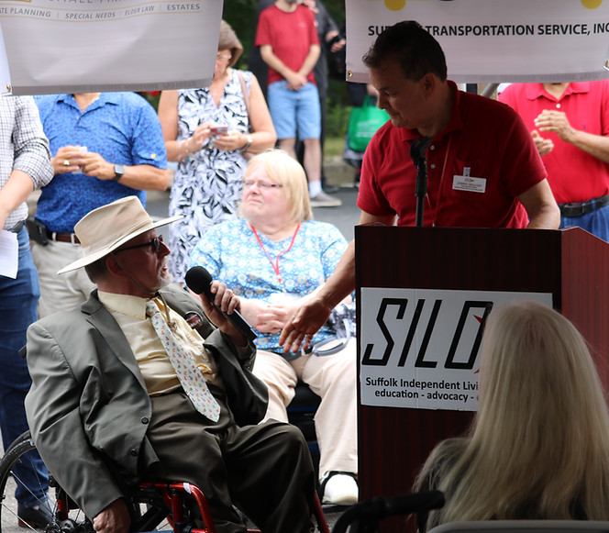

## August 9th is National Book Lovers Day Written by Judy Wieber

Have you read an enjoyable book lately? Well, if you are a lover of self-help books like me, I would recommend that you read: “Atomic Habits” by James Clear. That is, if you haven’t read it already.   Not only will you find the book full of practical tips on how to stick with and develop good new habits, but he provides you with his website where he gives you access to other books of interest and worksheets to help check your progress.

​

The book starts out describing a traumatic incident that occurs while the author is in high school, and how in some small way the experience changed his life for the better. He then goes on to explain, as he calls it, his “four laws of forming a habit”. Cue, Crave, Response and Reward, the fundamentals of habit formation are examined and applied.

So, if you are looking to develop some proficient reading habits, or cool off on a hot summer’s day, why not head over to your air-conditioned public library and check out “Atomic Habits.” It’s a delightful way to cool off on a hot summer’s day, while reenforcing some good habits. (wink, wink)

## We Have Might Written by Judy Wieber

We have might; we have grit; we have determination!

[>Click for link to song, The Greatest Showman Cast - This Is Me<](https://www.youtube.com/watch?v=wEJd2RyGm8Q)

Crank up the volume of your music device and celebrate! Listen to the words of the music that sings our song: “I know there is a place for us, we are glorious!”

July was Disability Pride month. Though this is August’s newsletter, I would be remiss if I did not write about the pride we have for ourselves and what we are doing, even though we have disabilities. When I mention disability, I mean a condition that effects our lives so profoundly. It affects us in ways where our activities of everyday living have received a strident blow. I mean activities that most people can do without aid:  getting up out of a chair or bed, standing, walking, navigating around, grooming, dressing, feeding oneself, communicating, reading, writing, reasoning. Yet, despite these obstacles. We have learned new ways of living. We have adapted ourselves by practicing techniques and technologies to circumvent the roadblocks. We have demanded, asked for our words to be heard. We are not going to be left behind because our bodies and our nervous systems do not always cooperate. We have talent. We have dreams and aspirations. We have feelings. We have asked to be heard and understood that we too want to have success in reaching our goals, despite the extra things we may have to do. We want to be a part of the bigger picture. Do not forget about us. We are here. We are not going away. Include me, include us. We are people too. We demand respect and dignity, and we have as much right as everyone to the right of “life, liberty, and the pursuit of happiness!

July 26, 1990, the Americans with Disability Act was signed into law by President George W. Bush. Watch the actual signing:  
[>Click for link to signing of the ADA<](https://www.youtube.com/watch?v=9gsGiszvyjQ)

 SILO celebrated the 33rd year anniversary on the grounds of SILO Friday, July 21, 2023. We heard from a representative from our state New York Senate, many County Legislators, and Brookhaven Town government, and the Director of the Suffolk County Office for People with Disabilities. Some points that seem to ring through: It takes cooperation amongst the three levels of government to meet the needs of the people they govern. Recognizing people’s ability, and flexibility to adapt is essential. When people come out and express their needs, things happen. Communities need to be built and preserved. When we all work together to move in one direction; we are a force not to be reckoned with. Disability issues are not bipartisan, they are not political, it can affect you whether you are Democratic or Republican. It crosses and touches everyone’s life from individuals to family members to American citizens to human beings.

So much is now being done to vote securely privately and independently. Shame on us if we do not take advantage of our power to exercise this right. Vote! Vote! Vote!

We need to take special notice of those who have supported us, and the ways we can support them.

A special thanks to Joseph Delgado and his resolute staff for hosting our 33rd anniversary celebration of the ADA. Thank you to all the sponsors and vendors, and a special thanks to all the elected officials who came out and made themselves available and accessible to talk to us.

​

Frank Krotschinsky, Director of Suffolk County Office for People with Disabilities, with Associate Director of the Office for People with Disabilities, Constantine Tino Ioannidis

John Corrado: President of Suffolk County Accessible Transportation

Brookhaven Town Supervisor, Ed Romaine

Legislator Nicholas Caracappa with Robert Martinez District 4,

Michael Anthony Iasilli, aide to Legislator Bridgett Fleming, District 2

Legislator, Dominick Thorne, District 7

Legislator Sarah Anker with Dorothy Cavalier, District 6

Legislator Steven J. Flotteron, District 11

Luis Montes Brito representing Legislator Sam Gonzalez, District 9

Undersheriff Steven J. Keuhhas- Suffolk County Sheriff’s Office

Councilman Jonathan Kornreich

State Assemblyman, Joe DeStefano

Timothy Rothang representing Legislator Jim Mazzarella, District 3

Shawn Hyms representing NYS Assemblyman, Doug Smith  
Nicholas DeVito representing Senator Weik's office  
Brian Zimmerman representing Senator Monica Martinez

Silver Sponsor: Suffolk Transportation Service

Bronze Sponsors: Aidwell Healthcare, Bulovas Restorations, FREE, Fratello Law, Bryan Skilled Home Care

Other sponsorship and promotional tables:

Brandow Law, Amber Court Communities, Jacqueline Delpriore- Longbridge Financial, Head Injury Association, Ridgewood Savings Bank, YAI, ClearCaptions, United Healthcare, RES Home Care, Fratello Law, Emics Elder Care, LifeVac, Equal First Aid, Zwanger Pesiri, Smart Start Centers, New York Health Care, Family Are We Personal Care, H&J Medical Supplies, Avoca Solutions, Evolving Gait Physical Therapy, College Hunks, Peter’s Fruit Company, Rocking Horse Farms, Chick-fil-A, JPCE Consulting Engineers, Visually Impaired Persons of Suffolk, EJ’s PJs, Sheriff’s Dept.

Raffle Basket Sponsors: Furniture Bazaar LI, Ridgewood Savings Bank, Rudi's Bar and Grill, All Metro Health Care, Access Family Services, Ability Health Care, Alliance Services, Cheryl Hecht, Suffolk Pro Cycles, LifeVac, Long Island Ducks, NY Rangers, NY Mets, NY Giants, NY Jets, NY Islanders, SILO Board Chair Mary Ann Sciacca, SILO Board Secretary: Geri DePersio, Donna Koslowski, Blaise Couvertier and family, SILO administration, Open Doors Dept, Housing Dept. RRDC, and PIP.

The following is a list of links, celebrating with music, to celebrate our accomplishments:

[>Click for link to song, Katy Perry- Roar<](https://www.youtube.com/watch?v=CevxZvSJLk8&list=PLk6n90VAXJUZQNQLVJHZSVXf0NlKqN-ei&index=17)

​

[>Click for link to song, Lady Gaga- Born this Way<](https://www.youtube.com/watch?v=3Vzrr64ZrVU&list=PLk6n90VAXJUZQNQLVJHZSVXf0NlKqN-ei&index=18)

[>Click for link to song, Whitney Houston- I Didn't Know My Own Strength<](https://www.youtube.com/watch?v=Iw3WbIbeXEU&list=PLk6n90VAXJUZQNQLVJHZSVXf0NlKqN-ei&index=30)

ADA Celebration photo album: <https://www.facebook.com/media/set/?vanity=suffolkindependentlivingorganization&set=a.752321500237962>

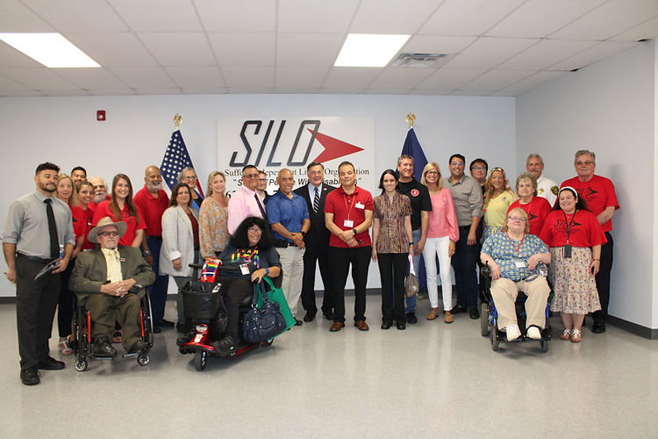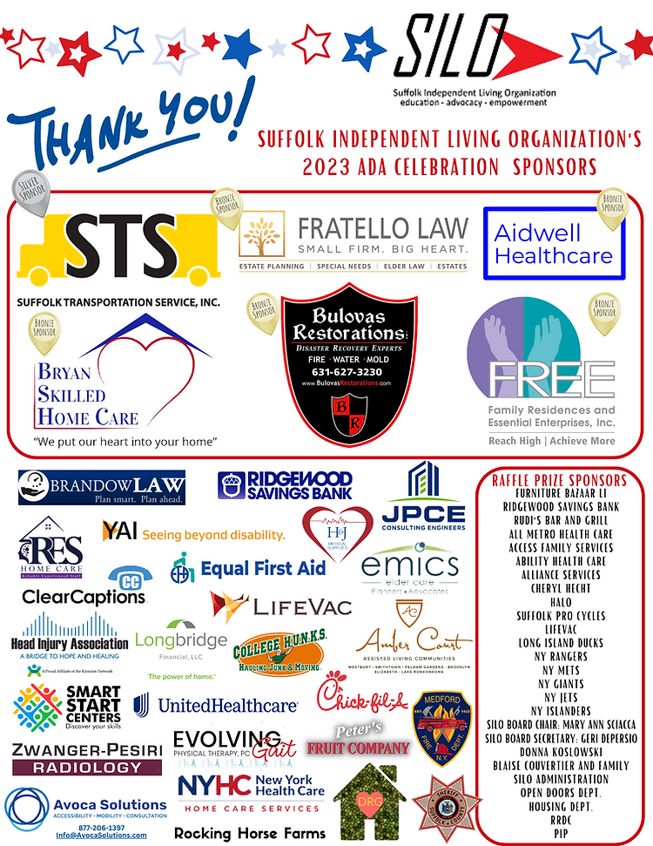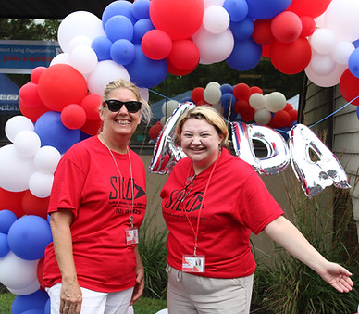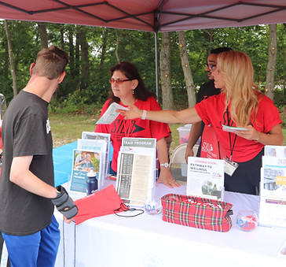

## ACUU Conference Written by Judy Wieber

SILO not only cares about the people we strive to support and inform, but we care about the professional growth and development of our employees. That is why our CEO, Joe Delgado, chose to send many SILO staff members to the Aging Concerns Unite Us Conference held in Albany at the end of June. The conference provided enriching workshops on Alzheimer’s, the latest trends in Artificial Intelligence to combat loneliness, and a review of virtual platforms being used to inform or survey many participants in a quick and secure manner.

​

One highlight was the demonstration of a new electronic care companion, made specifically with seniors in mind, ElliQ. Intuition Robotics has created a very user-friendly device, aiding in everyday living tasks, and giving a sense of companionship and empathy. It will have intuitive conversations, remind you of appointments or medication management, play music, games and more. Our staff was so impressed by ElliQ and it’s easy-to-use capabilities, that we are looking to obtain and distribute them to SILO program participants. Another highlight was  “a reboot” of some popular Hasbro board games: Scrabble, the Game of LIFE, and Trivial Pursuit. Together with Ageless Innovations, Hasbro has adapted these favorite past- times to better include the elderly population and allow for play across the generations. If you would like to learn more, please give SILO a call.

​

August 21st is National Senior Citizen Day; why not reach out to a senior and let them know how much you appreciate them?

I would like to make a shout out to my Mom, Mary: “I love you Mom and I appreciate everything you have taught me!”

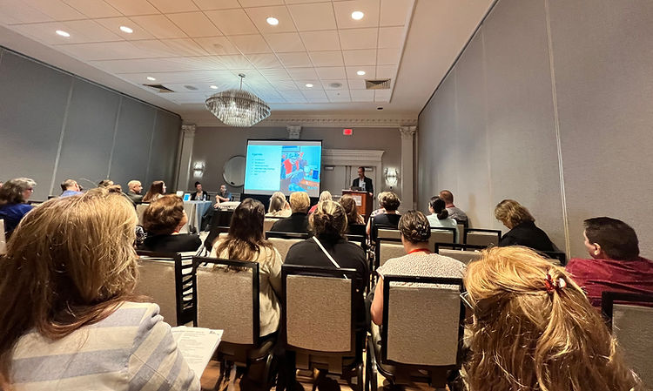

## [OKO OKAY!](https://apps.apple.com/us/app/oko-ai-copilot-for-the-blind/id1583614988) Written by Judy Wieber

What’s that? Can you hear it? “Hear what?” you might ask. It’s my new app on my cell phone.  What new app? OKO is an app developed in Belgium for the visually impaired. Most of us in the visually impaired community are familiar with Accessible Pedestrian Signals, APS. You know, those traffic pedestrian signals that beep, talk and vibrate.

The ADA made it possible for folks who are blind to request an APS be installed at an intersection they use in their neighborhood. The request must include a strong need. Just wanting access is not enough. The request must be sent to the level of government responsible for the intersection, state, county, or town. Then, the municipality will decide on whether they consider it called for. The Accessible Pedestrian Signals are often granted on state roads and are harder to obtain on the county and town levels. This must have to do with the funds available. Who wouldn’t want to give blind people the tools they need to cross a street safely?   What they do is give audible and tactile access to visual information expressed by pedestrian signals. You know, they used to flash DO NOT WALK and “WALK. Now they show a red hand for DO NOT WALK, and a pedestrian walking in white on a black background, for WALK. I am sure this change was made to help the print impaired and people who speak languages other than English.

An Accessible Pedestrian Signal still has the red hand or person walking, but it has been adapted to emit a pitch to find the device. Once you find the device, you push the button which is an embossed arrow pointing in the direction of the street to cross, another adaption to the original signal. The signal will then verbally announce to the pedestrian to “Wait”. Once the traffic light changes, it will again, audibly state, “The walk signal is now on, (giving the name of the street)”. It will also play a cadence and give you a countdown on how many seconds still are before it changes back to “DO NOT WALK.” The embossed arrow will also vibrate when the walk signal appears, giving a person who is both deaf and blind access to the visual information.

Now the company, Ayes, started in Belgium, has come up with another way to access this vital environmental information.  “What?” you might ask. No letter writing, or petitioning local government, to adapt the ped. head? Every intersection with a pedestrian signal using a red hand and a white person as their display, can now be made accessible to the blind with no wait for funding, or judgement? The answer is YES.

This new app is free and can be supported by iPhone 8 and above, and you can get it at the Apple Store

How it works: You first need to buy a lanyard to wear your iPhone at chest level. Once you download the app on your phone, using voiceover, ask Siri to open OKO while at the intersection. A pedestrian would then line themselves up to the intersection and make a 180-degree turn, rotating the upper part of your body 90 degrees to the left, and then rotating yourself back 90 degrees back to the right, making a full 180-degree rotation. If there is a pedestrian signal in that area, OKO will pick it up and start emitting a slow beeping sound if signal is displaying the red hand. If the signal is showing a pedestrian white on black background, the beep will automatically pick up speed and then will play a quicker cadence to countdown the seconds remaining. If the beeping stops while crossing the street, slightly rotate in the opposite direction about 45 degrees. No sound means you have walked out of your camera’s view of the signal. Rotating back slightly in the opposite direction, will help to compensate for a natural tendency to drift out of the crosswalk. Once the signal is in view of the camera, the beep will resume, and a pedestrian will now be on the correct path.

I had an opportunity to give this app a try and I personally found it to be a help. Presently, it is free, and the developers are hoping to keep it that way. However, they would appreciate any feedback a user could give them to make the product better.

Also, please keep in mind, a person should not use this app without having been trained in mobility and orientation from a professional mobility instructor. Pedestrian signals are to be used as an aid; they are not the only thing used to cross streets. A person must use all their senses and cognitive judgement to cross a street safely. Not every driver follows the rules of the road, and caution should always be exercised when doing so.

You can download the OKO app [>HERE<](https://apps.apple.com/us/app/oko-ai-copilot-for-the-blind/id1583614988)

You can learn more about OKO from its manufacturer, Ayes, on their website: [www.ayes.ai](https://na01.safelinks.protection.outlook.com/?url=http%3A%2F%2Fwww.ayes.ai%2F&data=05%7C01%7C%7C604fbfd7399e4e6c387c08db77e4fb5e%7C84df9e7fe9f640afb435aaaaaaaaaaaa%7C1%7C0%7C638235597573358653%7CUnknown%7CTWFpbGZsb3d8eyJWIjoiMC4wLjAwMDAiLCJQIjoiV2luMzIiLCJBTiI6Ik1haWwiLCJXVCI6Mn0%3D%7C3000%7C%7C%7C&sdata=B%2F%2F6gRKfVA1VBu6IvUZNdLFkHCGw828QnxcORmPNrcM%3D&reserved=0)