**October 2022 Newsletter**Article by Judy Wieber

October is National Disabled Employment Awareness Month. Wow! Who knew there was a whole month dedicated to the awareness of employment of people with disabilities? I did not know, and I have a disability. You can tell by the verbiage, it has been around for a while; In fact, since 1945. I am Pointing out; the word “people” is nowhere to be found in the title. I am not trying to be critical here, and perhaps it was just an effort to shorten the title, but at some point, along the journey, it became important to say: “a person with a disability”. Making the focus on “person first.”

People, that is what we are. We are all people, trying to get along in life. Each one of us, whether we have a disability or not, has goals, aspirations, dreams, passions. Unfortunately, money is required to achieve most of these things, but not all. Employment of people does so much more than provide a person with the financial means to sustain life, food, clothes, shelter, etc. Employment gives a person purpose, direction, hope. We, however, know all of this. I am not saying anything new.

If I am not saying anything new, then why is it that the employment of people with disabilities is still not what it could be? Again, I am not trying to be cynical and there are many people who are working having a disability. They may have had to fight for their right to work, or fight for adaptions in their place of employment, but employed none the less. They are employed because of laws and advocates, whether it was self-advocacy, or legal representation. More than that, they are employed because of guts, and perseverance. The willingness not to give up on what they believe in, themselves. Though applause, however, are not just reserved for the employees with disabilities, but the employers who were not afraid to employ us. Hats off to all the employers who have and continue to employ. Employers who are willing and dedicated to educating themselves on the adaptive equipment and assistive technologies available, making the transition quick and smooth. Kudos to those employers who hire Information Technology Specialists versed in these special adaptive technologies along with the mainstream gadgets that are supporting our workplaces today.

According to, an article written by Karen Herson, a member of Forbes Business Council, published in Forbes Magazine in December2021, hiring people with disabilities, just makes good business sense.

Herson lists and explains seven good reasons to hire people with disabilities. I would encourage the readers of this article to visit her article at: https://www.forbes.com/sites/forbesbusinesscouncil/2021/12/03/seven-reasons-why-hiring-people-with-disabilities-is-good-for-business

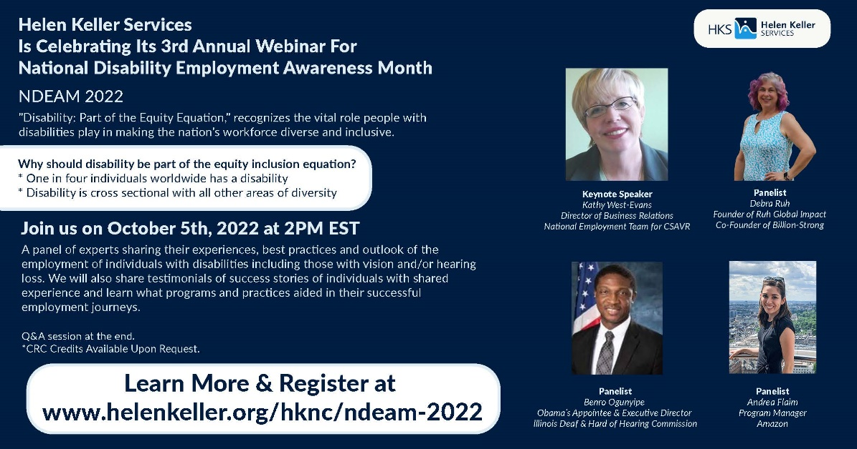

*SILO’S Self Advocacy Conference*

Article by Judy Wieber

Come One, Come All!

SILO’S Self Advocacy Conference, happening October 14th, should serve to be an inspirational and informative one. When you hear the lineup of interesting and exciting guest speakers, you will only want to attend.

I know I am very impressed, learning about these three men and the stories they must share.

Ken Kunken, a District attorney and former rehabilitation counselor, now a motivational speaker will inspire all with his story. A story of determination and triumph.

At age 20, While attending Cornell University in the pursuit of a degree in Operational Research Information Engineering, Ken suffered a spinal cord injury leaving him paralyzed from the neck down. Ken will walk us through his journey of struggle and success.

Michael Kalberer a native Long Islander and inspirational speaker, will tell us about his story living with dual disabilities and his participation in revolutionary gene therapy treatment. One of the first to receive this amazing advanced medical procedure. A procedure to help restore some of his lost vision, resulting from Lebar’scongenital amaurosis, LCA.

The third and last but not least speaker is Bobby Grogan. Blind from birth and a son of blind parents, is a parent himself. In 2002, he became Burger King’s first manager who was legally blind. From 2006 until the birth of his daughter Katie in 2018, Bobby worked for a research company, BPA International, where he excelled.

He now holds the hardest and most rewarding position he will ever hold, caring for his four year old daughter.

Come join us on October 14th, I guarantee, you will not be disappointed.

***Rakott Krumpli or layered potato***  
Recipe by Ecaterina Henter

Rakott Krumpli or layered potato is a traditional Hungarian casserole. This is an incredibly tasty, quite simple and quick dish to make.

It is a dish made with potatoes, sour cream, bacon, smoked sausage, hard-boiled eggs, cheese, and some butter for the bottom. It is a layered casserole with slices of each above mentioned ingredients layered onto each other and baked in the oven.

Some people leave out the bacon or/and smoked sausage. I usually leave out the bacon if I include cheese.

Approximate ingredients:

• 6 Potatoes, cooked in their skins

• 6 Hard boiled eggs

• Some Melted Butter (depending on the size of your dish)

• 4 tablespoons Fried and crumbled bacon

• 1 pound Smoked sausage (I use Kielbasa)

• Some Sour cream to spread on layers

• Some grated cheese for the layering and some additional sliced cheese to cover the top. I use 2-3 different kinds of cheese like Parmesan, shredded cheddar, or/and mozzarella cheese.

• Some Salt

In a large pot, cook the potatoes with skin on until it is done without being overcooked. Remove the potatoes from the water and set aside to cool, then peel and

slice them. (I Peel the boiled potatoes while they're still warm (almost hot because it is easier to peel them.)

You can slice the potatoes directly into the tray when layering the dish.

In another pan, boil the eggs for 10 minutes. When eggs are cooked, place them in cold water. (Once they are cooled, they will be easier to peel.)

Then, brake and peel the eggs and with an egg slicer or with a knife, slice the eggs.

Cut the smoked bacon into small cubes, and then, cook them until golden (half-done).

Cut the sausage (not too thin) slices. Fry these skinless smoked sausage rings in a pan.

Grate the cheese, if needed. You will also use some sliced cheese to cover the dish at the end.

Preheat the oven to 350F (180 C).

Now, when everything is ready – start to layer the dish into an ovenproof glass dish.

Brush the baking dish with the butter. (Some people grease the baking tray with the fat from the bacon.)

Place one layer of the sliced potatoes, then sprinkle with salt. The second layer is the sliced sausage, and then some bacon. Next, put one layer of graded cheese and then some sliced eggs over that. Next, cover it with the sour cream.

Repeat these a few more times: potatoes, (salt), sausages, bacon, cheese, eggs, sour cream.

Finish it with a layer of potatoes, covered with the sliced cheese.

Bake it in the preheated oven for about 30 minutes or until the sliced cheese is nicely browned, the sausages released their fat, and the cheese is nicely melted.

Let it stay and cool about 10-15 minutes, then serve.

You may serve some pickles on side.

ENJOY!

***October is National Domestic Violence Awareness Month***Article by Judy Wieber

Another important topic we need to focus our attention to is the prevalence of domestic violence, occurring in our communities. October is National Domestic Violence Awareness Month.

On any typical day, there are more than 20,000 phone calls placed to domestic violence hotlines nationwide. Taken from domestic_violence-2020080709350855.pdf Fact sheet at: www.ncadv.org. Unfortunately, people with disabilities are not exempt from this hardship.

In November of 2021, the Bureau of Justice Statistics (BJS) reported the following facts, regarding victimization of people with disabilities:

The incidence of serious violent crime against persons with disabilities was more than three times the rate for persons without a disability.

40% of disabled people who had been victimized were victimized by people they knew well, or casually.

11% of these crimes were committed by relatives. (Taken from an article written by Audrey Demmitt, APH website.)

For more information, and to find out how to get help, please contact The National Domestic Violence Hotline at 1-800-799-SAFE, or www.TheHotline.org, Please visit the National Coalition Against Domestic Violence web site: http://www.ncadv.org for more information and fact sheets.

Article by Judy Wieber

Feel like having a little fun? Let’s play a game. How good are you at playing the $10,000.00 pyramid?

“Tap, Tap, tap”; “I am very long”; “I have white reflective tape”; “I fold up and fit in your pocketbook; or I can hang on a man’s belt loop”. “Once folded I can fit under a chair; in the corner of a room.” My handle looks like a golf club.” “People who have low vision, or no vision depend on me to explore the world around them.” “I am an extension of their right arm”. “I help keep them safe, navigating them around obstacles, across busy streets, and down stairwells.” “I have a very important job, I alert the general public that the person holding onto my handle is blind or has low vision.” Though I am not as cuddly or as cute as my counter mobility strategy, I do not require veterinarian visits, grooming, or food.” In fact, my users need to know how to use my services very well before they can even think of getting the other frisky smart furry traveling companion. Have you guessed it? If you thought: “things a white cane would say.” You would be correct!

How good are you at Jeopardy?  
(All answers appear backwards)

Clue: The date proclaimed to be: “National White Cane Safety Day. ” Answer: 4691 ,51 rebotcO

Clue: The U.S president who made the proclamation? nosnhoJ .B nedniL

Clue: Another name for White Cane Safety Day. yaD ssenerawA enaC etihW

How about unscrambling some of these words:

Dpenndineece

ovrienntmenn

sesenwar

Some fun Facts:

In 1921 an artist by the name of James Biggs became blind. In order to make himself more visible to motorists, Biggs painted his walking stick white.

A person who trains a person to use a white cane is called a Mobility and Orientation instructor.

Congress to this day still has not passed legislation, requiring a special license for this profession.

Walking in Rhythm is a technique used by a person using a white cane. It is also described as a two-point touch technique. The traveler taps two points directly in front of them, about 2 ½ feet in width, moving the cane in an arch like position, the traveler can then detect a clear path, avoiding any obstacles in front of them. The tapping sound the cane makes also helps a person orient themselves in space. The bouncing of sound and the blocking of sound can play a key role in navigation.

If you had as much fun as I did, getting some or all the answers correct, pat yourself on the back and consider yourself clever and very inclusive and aware of the needs of the blind and visually impaired in your community.